**Project Proposal**

**Technology and Standards for Geospatial Workflow**

**CROP INSURANCE WORKFLOW**

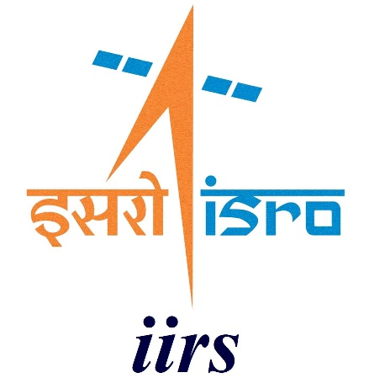

**Submitted by:**

Akanksha Singh (M.Tech ASD)

Vanamadi Sandhya Rani (M.Tech ASD)

Shreyas Sajeev T (M.Tech FED)

**Submitted to:**

Mr. Shiva Reddy Koti

Scientist/Engineer – SE

Geoinformatics Department,

IIRS, Dehradun

Project Proposal

**Topic: Crop Insurance Workflow**

**Introduction**

Agriculture is exposed to frequent risks of crop damage all around the world. In such a case, the idea of crop insurance schemes and their implementations have played an important role in agricultural risk assessments. Agricultural risk assessments have been there in different countries in different decades and time periods ​(Skees, 2005)​. Still there have been continuous improvements in the ways and approaches a crop insurance scheme is designed and the ways it’s assessed. With more and more technologic advancements, the need for developing more innovative and sound crop insurance products which will be useful for both developed and developing nations is required (​(Leblois et al., 2014). Better agricultural risk managements are required to address the current challenges of food security, farmer’s income security, and climate resiliency in agriculture. Rice holds immense importance in the country’s agriculture, economy, food security and cultural heritage. Hence, a risk reducing financial instrument like a crop insurance would help a lot in meeting the required goals of saving the crop.

**Evolution of Crop Insurance**

Traditional crop insurance was small-scale and retail in character when it was first presented to the nation in 1972. Comprehensive Crop Insurance Scheme (CCIS), one of the first large-scale national programmes, was introduced in 1985. It was followed by the National Agricultural Insurance Scheme (NAIS), the Weather Based Crop Insurance Scheme, and the Modified NAIS (MNAIS) in 2000 and 2010 (Department of Agriculture and Cooperation 2014). The assessment of loss and indemnity payment under the current crop insurance systems is determined by a region's crop yield index or weather index. There are three factors that limit weather-based crop insurance: (1) complex relationships between weather and crop yield; (2) insufficient representation of geographical variability in meteorological conditions; and (3) a lack of representation of dangers (pests and diseases) associated with weather ​(Leblois & Quirion, 2013)​ .Pradhan Mantri Fasal Bima Yojana (PMFBY), being implemented in the country from 2016, is an area-yield insurance contract with many positive features to compensate for multiple risks throughout the crop season. The Department of Agriculture, Cooperation and Farmers Welfare (DAC&FW), Ministry of Agriculture and Farmers Welfare, Government of India, is the nodal agency for executing PMFBY in the country. The operational guidelines for smooth implementation of PMFBY were documented in 2016 and revised in 2020 and made available to all the stake holders ([www.pmfby.gov.in](http://www.pmfby.gov.in/)).

**Scope of Remote Sensing Data in** **Crop Insurance**

Over the past ten years, a number of index insurance contracts that are based on yield or weather have successfully employed digital technologies like mobile apps and satellites to expand their coverage, lower their operating costs and premiums, and speed up the processing of claims in Africa ​(Raithatha & Priebe, 2020)​. The ability to closely monitor crops using numerous bio-physical indices has been made possible by recent, tremendous advancements in weather instrumentation and remote sensing technology. Once every five to twelve days, microwave and

optical data with modest resolutions of 10 to 20 m are accessible. To identify vegetation/crop health condition and any deviations from normal brought on by various threats including pests, droughts, and floods, satellite indices are incredibly helpful. The capacity to monitor crops in close to real-time has never been easier thanks to the increased availability of satellite data and weather indicators. The phenological stages of many crops, including wheat, paddy, soybeans, and maize, can be captured using commonly accessible Sentinel data, both optical and microwave, as demonstrated by ​(Veloso et al., 2017)​ . In comparison to meteorological indices like temperature and precipitation, crop insurance contracts utilising remote sensing-based vegetation health indices outperformed the latter. Satellite data with better spatial resolutions that cover crucial phases of crops would enhance the effectiveness of insurance even further (Möllmann et al., 2019). ​ Hence, remote sensing applications will give a spatial extent in assessing the flood inundated regions which would aid in better estimation of the loss and damage and accordingly benefit the famers by giving the insurance for their crops.

**Objectives**

1. To assess the workflow of a crop insurance scheme in the flood affected area.
2. To compute the total area of agriculture fields affected by floods using microwave satellite data.

**BPMN (Business Process Model and Notation)**

The BPMN we created for crop insurance companies is as follows:

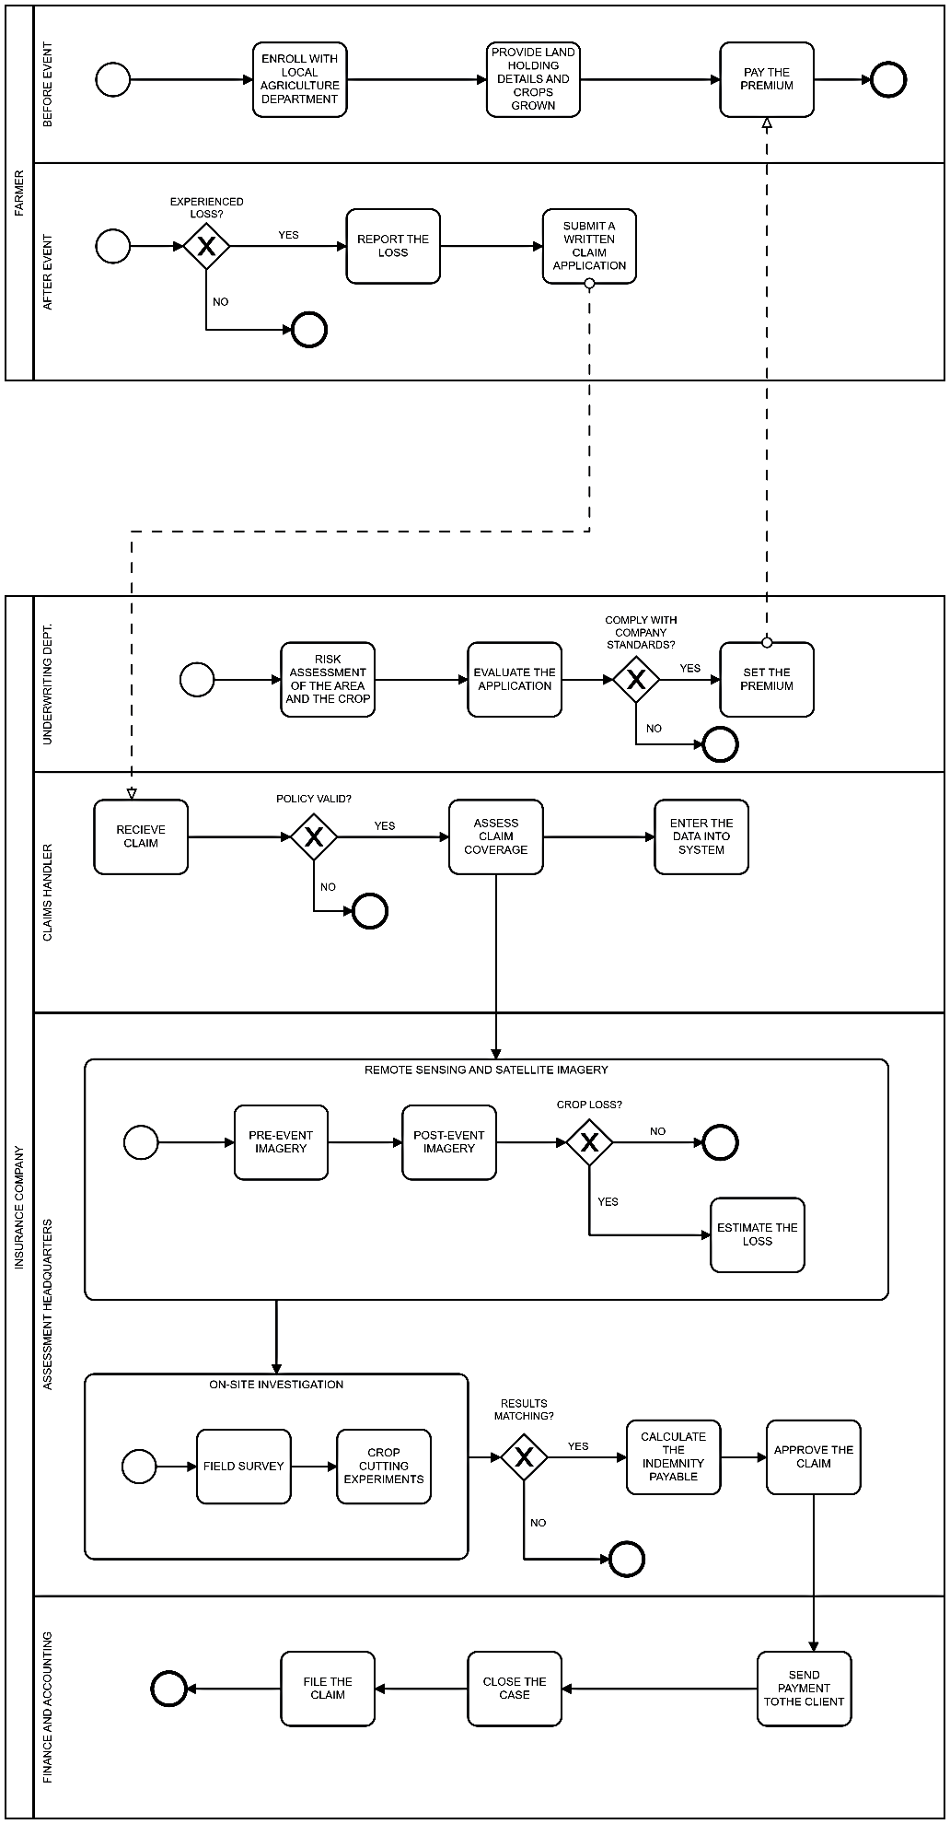

**Proposed Methodology:**

**Sentinel-1 GRD Image**

**Automatic Preprocessing**

**Before Flood Image**

**After Flood Image**

**Change Detection Algorithm**

**Difference Layer**

**Crop Mask**

**Affected Cropland**

**Image**

**Compute Area**